NAME: GINKA HEMDEEP REGNO:RA1911030010072

Assignment-1

IMPLEMENTATION OF TOY PROBLEM

Camel and Banana puzzle

A person has 3000 bananas and a camel. The person wants to transport the maximum number of bananas to a destination which is 1000 KMs away, using only the camel as a mode of transportation. The camel cannot carry more than 1000 bananas at a time and eats a banana every km it travels. What is the maximum number of bananas that can be transferred to the destination using only camel (no other mode of transportation is allowed).

CODE:

total=int(input('Enter no. of bananas at starting'))

distance=int(input('Enter distance you want to cover'))

load_capacity=int(input('Enter max load capacity of your camel'))

lose=0

start=total

for i in range(distance):

while start>0:

start=start-load_capacity

#Here if condition is checking that camel doesn't move back if there is only one banana left.

if start==1:

lose=lose-1#Lose is decreased because if camel try to get remaining one banana he will lose one extra banana for covering that two miles.

#Here we are increasing lose because for moving backward and forward by one mile two bananas will be lose

lose=lose+2

#Here lose is decreased as in last trip camel will not go back.

lose=lose-1

start=total-lose

if start==0:#Condition to check whether it is possible to take a single banana or not.

break

print(start)

OUTPUT:

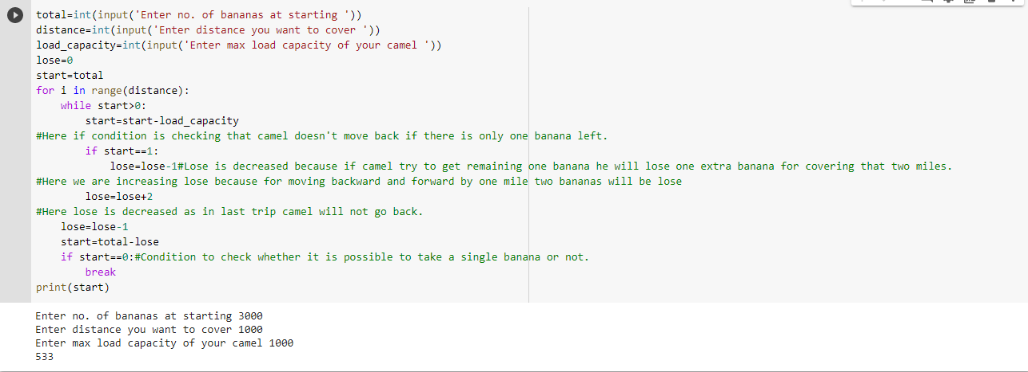

**TIC-TAC-TOE**

**CODE:**

import random

class TicTacToe:

def __init__(self):

self.board = []

def create_board(self):

for i in range(3):

row = []

for j in range(3):

row.append('-')

self.board.append(row)

def get_random_first_player(self):

return random.randint(0, 1)

def fix_spot(self, row, col, player):

self.board[row][col] = player

def is_player_win(self, player):

win = None

n = len(self.board)

# checking rows

for i in range(n):

win = True

for j in range(n):

if self.board[i][j] != player:

win = False

break

if win:

return win

# checking columns

for i in range(n):

win = True

for j in range(n):

if self.board[j][i] != player:

win = False

break

if win:

return win

# checking diagonals

win = True

for i in range(n):

if self.board[i][i] != player:

win = False

break

if win:

return win

win = True

for i in range(n):

if self.board[i][n - 1 - i] != player:

win = False

break

if win:

return win

return False

for row in self.board:

for item in row:

if item == '-':

return False

return True

def is_board_filled(self):

for row in self.board:

for item in row:

if item == '-':

return False

return True

def swap_player_turn(self, player):

return 'X' if player == 'O' else 'O'

def show_board(self):

for row in self.board:

for item in row:

print(item, end=" ")

print()

def start(self):

self.create_board()

player = 'X' if self.get_random_first_player() == 1 else 'O'

while True:

print(f"Player {player} turn")

self.show_board()

# taking user input

row, col = list(

map(int, input("Enter row and column numbers to fix spot: ").split()))

print()

# fixing the spot

self.fix_spot(row - 1, col - 1, player)

# checking whether current player is won or not

if self.is_player_win(player):

print(f"Player {player} wins the game!")

break

# checking whether the game is draw or not

if self.is_board_filled():

print("Match Draw!")

break

# swapping the turn

player = self.swap_player_turn(player)

# showing the final view of board

print()

self.show_board()

# starting the game

tic_tac_toe = TicTacToe()

tic_tac_toe.start()

**OUTPUT:**

